RELATIONAL DATABASES PROJECT


Database for a Football Association


Made By: Mentor:
Djevair Avmedoski CSE 1163 Dr.Dijana Capeska Bogatinoska
Elhan Musoski CSE 1193
Art Dilaveri CSE 1169

1. Introduction to the problem

A Football Association can be defined as a group of football fanatics who have the privilege of keeping track of everything going on in the footballing world.
It's responsible for everything connected to football, whether those are clubs, players, leagues, transfers, and most notably International football.

For each Football Club, the database keeps track of the club's name, id, the city in which it's located and the year it was established.
A club can have many players playing for it, and many players can play for many clubs throughout their careers. When they change clubs, we say that a player 'Transfers' from one club to another
A club can only ever play in one league, but one league is comprised of many football clubs

The database also keeps track of the Players and their attributes such as id, first name, last name, age, in-game position, kit number, and which country they represent on the international stage.

A player can only represent one country, but one country can be represented by multiple players.
The Country has its own attributes such as name, rank, and personal id.

Each country has its own League.
One country can have multiple minor and major leagues but said leagues can only be played in one certain country.
The league has its own name, id, and number of teams participating in it.

Each player has a specific Sponsor that sponsors them.
The database also keeps track of said sponsor and its components such as name, id, and length of contract it offers.
One sponsor can sponsor many players and many players can be sponsored by many sponsors.
Also, the sponsor sponsors a certain club.
One sponsor can also sponsor multiple clubs and multiple clubs can have many sponsors.

The last piece of info the database keeps track of is Coaches/Managers.
The attributes of a coach/manager are: first name, last name, personal id, and age.
Many coaches can coach many football clubs throughout their careers and many clubs can be coached by many coaches.
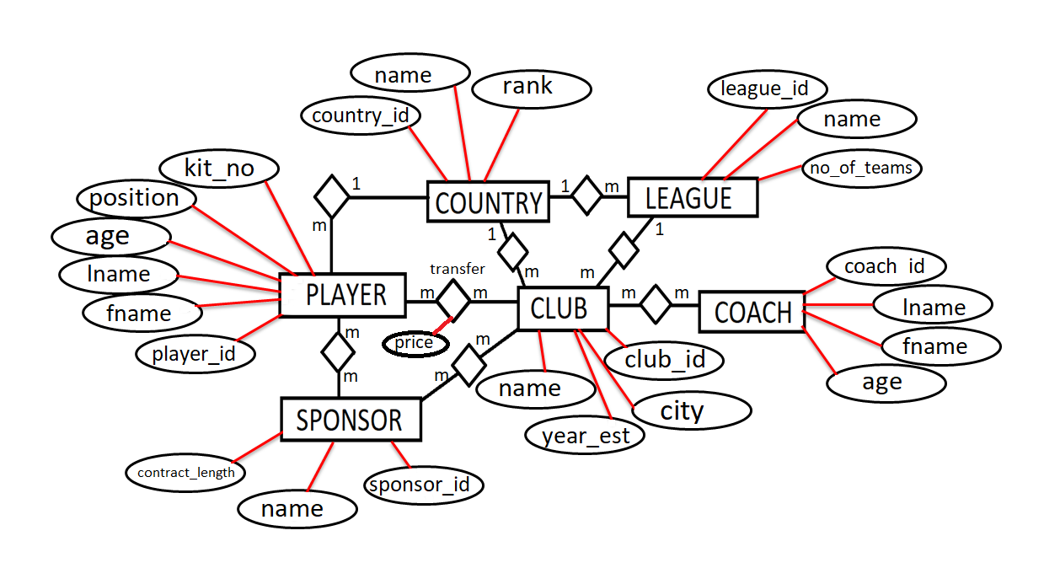

2. The Relational Model

Club ( club_id, name, city, year_est, country_id*, league_id* )
Player ( player_id, fname, lname, age, position, kit_no, country_id* )
Sponsor ( sponsor_id, name, contract_length )
Country ( country_id, name, rank )
League ( league_id, name, no_of_teams, country_id )
Coach ( coach_id, lname, fname, age)
Transfer ( player_id*, club_id*, price )
Club_Sponsor ( club_id*, sponsor_id* )
Club_Coach ( club_id*, coach_id* )
Player_Sponsor ( player_id*, sponsor_id* )


PRIMARY KEY FOREIGN KEY

3. SQL DDL code to create a database, and implementation using SQL Server

Let’s firstly begin with labeling, creating and using our Football Association Database.
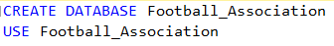
Now, we can begin with creating out tables for the database.
First we have the table COUNTRY:
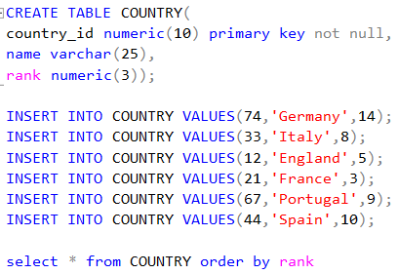
The result is:
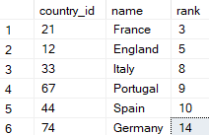
Then, we create the table COACH:
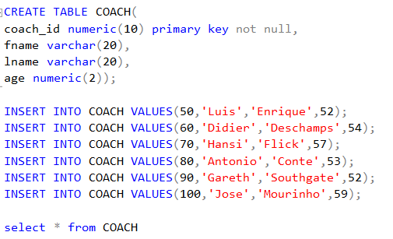

The result is:

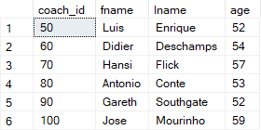

Next, we create the table SPONSOR:
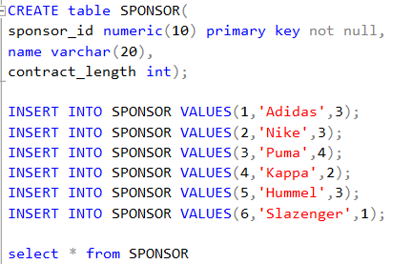
The result is:
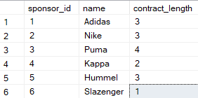

Next, we create the table PLAYER:
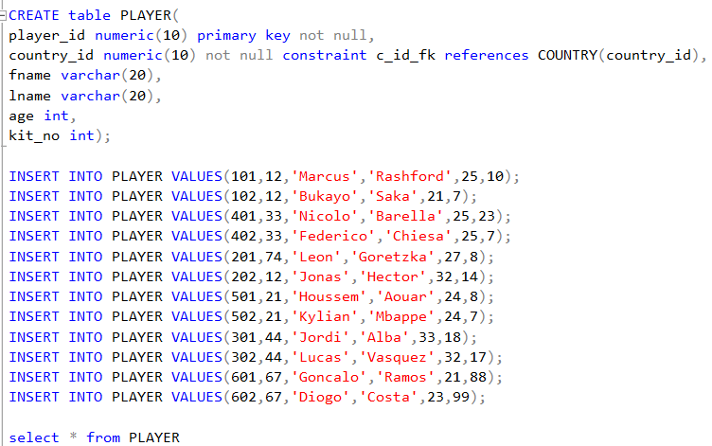
The result is:
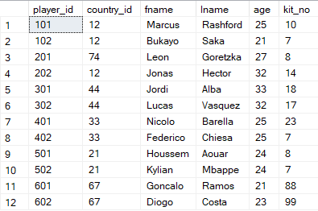

Then we have the table LEAGUE:
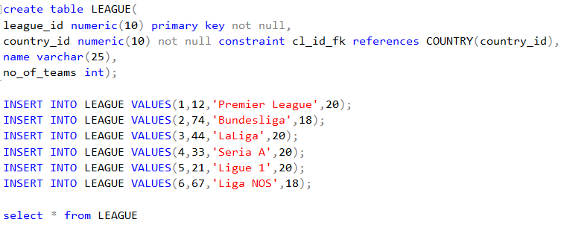

The result is:
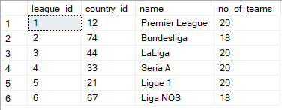

Next we create the table CLUB:
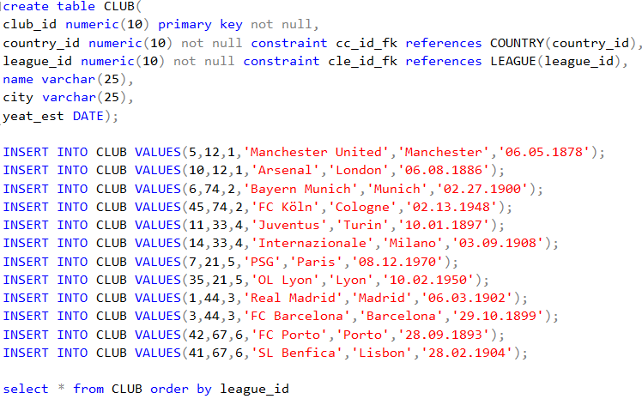
The result is:
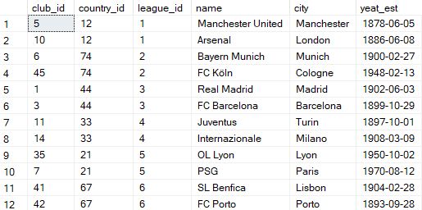

Next we have the CLUB_SPONSOR table:
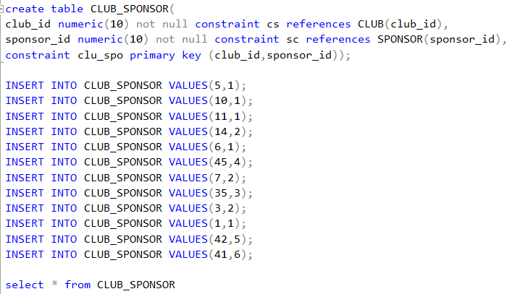
The result is:
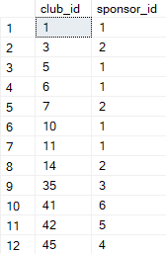

The next table is TRANSFER:
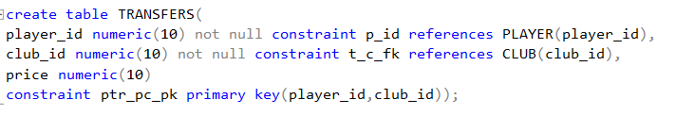
Then, we create the table CLUB_COACH:
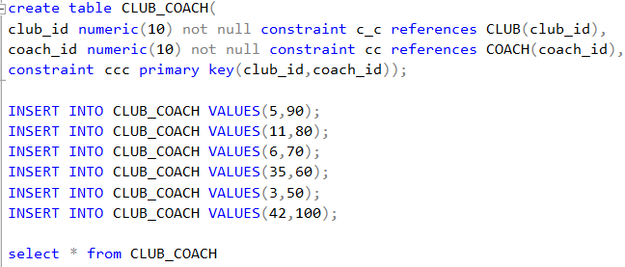
The result is:
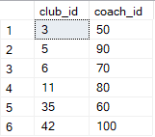

And the final table that we have to create is the table PLAYER_SPONSOR:
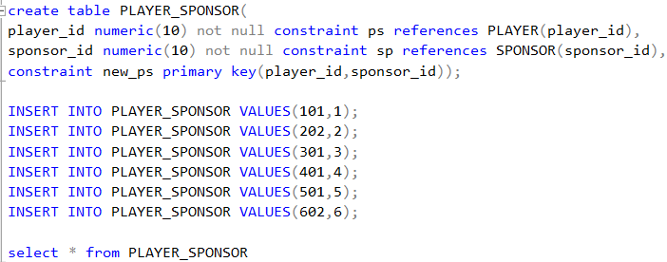
The result is:
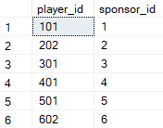

4. SQL DML code to create some queries, and implementation using SQL Server

Now that we have created and inserted some values into our tables, let’s give a few examples of SQL DML code to play around with some queries.

1. Make a report that will give us the first and last name, kit number of all French players. Order it by kit number.
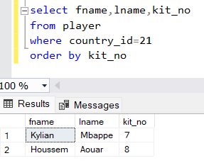
2. Make a report that will give us the name and club id of all clubs where the club is greater than 20.
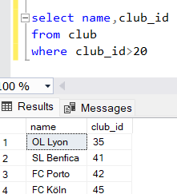

3. Insert into the player a new player for both Manchester United and Bayern Munich. Display the table.
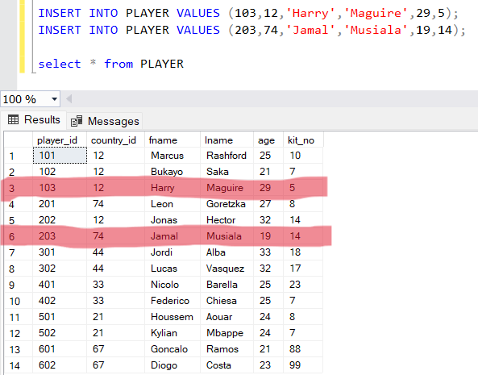
4. Make a report that will give us all details about CLUB and LEAGUE, where the number of teams in the league are greater than 19. Order by league id.
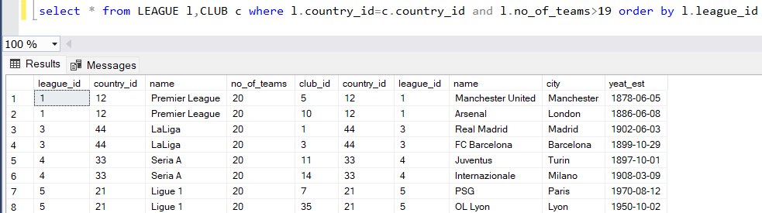

5. Find the clubs name and id where the country represents ‘Germany’, except the club ‘FC Köln’.
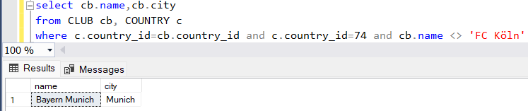

6. Make an Inner Join Query between PLAYER and COUNTRY that displays the first name and last name of the players.
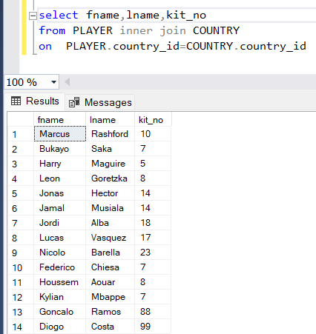
7. Update the league_id to 7 for all teams with the club_id=7 and 35
8. Count the number of clubs, excluding ‘FC Porto’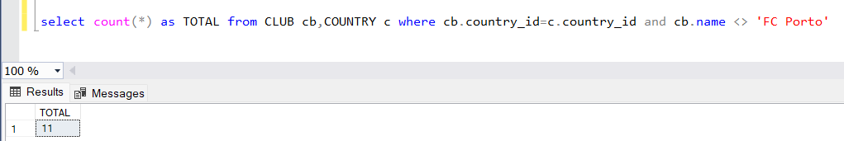
5. Conclusion

As we can see from some of the above mentioned examples, we can see that in order to make a stable, aesthetically pleasing and most importantly a functioning database we have to start off with creating/solving the given problem at hand.
Next we make an ER (Entity Relationship) Diagram and a Relational Model.
Then the most interesting, but also time consuming process is creating and working with SQL Code.
Connecting the tables with primary and/or foreign key can be a bit of a hassle, but that can all be solved with a bit of practice, hard work and determination.
We use some very simple, but interesting queries and examples, which might not win us a Nobel Prize or a Competition, but can help us and any novice to get a better understanding in creating a database.

6. References
Here are some websites we use to get some info regarding out project:
FIFA Rankings - https://www.fifa.com/fifa-world-ranking/men?dateId=id13869
Club Power Rankings - https://brandirectory.com/rankings/football/table
Player Info - https://www.transfermarkt.com/
Some other general information - https://www.wikipedia.org/

